**Phase 3**

The smart toilet restrooms have both hinged or sliding doors. A radar-driven user detection system is installed in it. Patented anti-syringe washbasin. SOS push-button for emergency calls and PTCall bidirectional emergency call system. Touchless access, or access with multi-coin cash box or contactless.

**AI and ADS**

A smart toilet equipped with such sensors shares its data with a central cloud-based platform. This cloud-based platform allows civic authorities to monitor toilet conditions to ensure cleanliness. It can alert sanitation workers, too, via text messages or voice calls.

It is introduce to use and maintain the toilets in the clean and hygienic way. The project is based on IOT concepts using different sensors like smell sensor, dirt sensor, sonic sensor, RFID reader, Database. Using these materials we are trying to provide the clean toilets and create the awareness among the people.

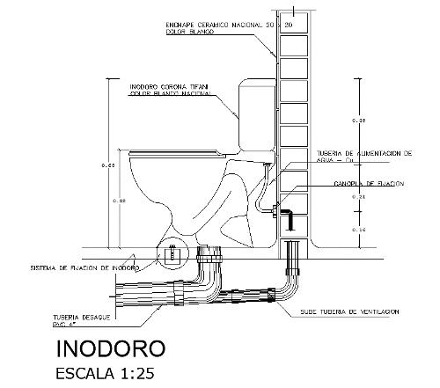

**Digital-to-Analog Converter**

In the world of electronics and technology, DAC plays a pivotal role in converting digital signals into analog signals. This conversion is essential for various applications, ranging from music playback to telecommunications.

Device that enhances the quality of audio for headphones and speakers by converting it into an analog signal. The superior quality of the analog signal significantly improves audio playback, particularly for music and movies.

**Internet of Things**

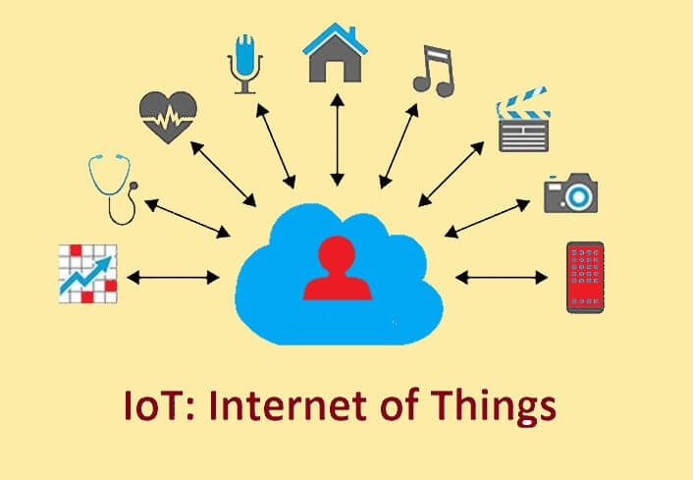

The term IoT, or Internet of Things, refers to the collective network of connected devices and the technology that facilitates communication between devices and the cloud, as well as between the devices themselves.

IoT applications span numerous verticals, including automotive, telecom and energy. In the consumer segment, for example, smart homes that are equipped with smart thermostats, smart appliances and connected heating, lighting and electronic devices can be controlled remotely via computers

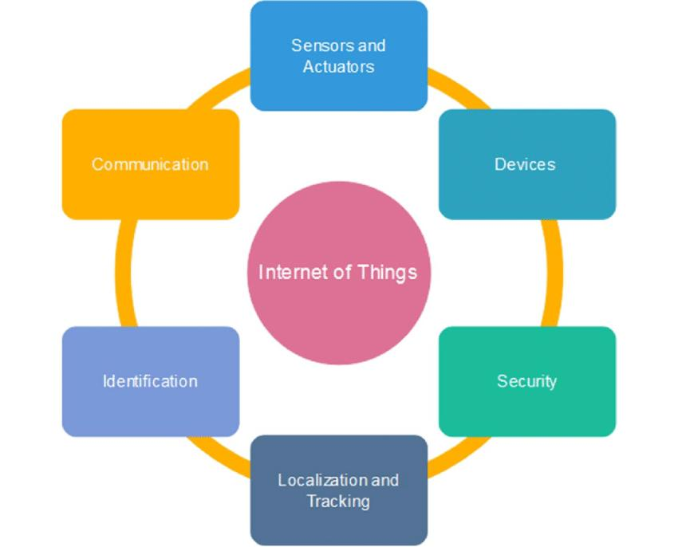

**Computer-Aided Design**

CAD is an advanced software for creating designs and generate technical drawings in 2D and 3D by architects, engineers, drafters & artists.

Software is a useful tool commonly used by bathroom retailers and designers to create plans for their customers, as well as generate renders of their customer’s bathrooms, to show them how the final project will look.

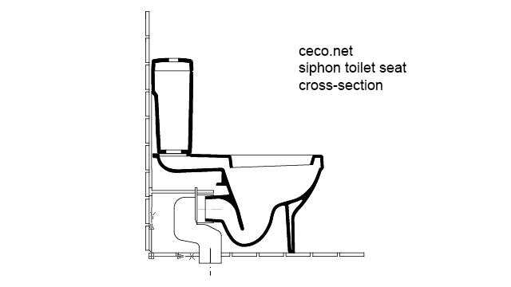

**NOTE**

File name : **IOT based on smart public restroom_ phase 3**